5 Children’s Books to Continue the Discussion About Diversity
Your family has likely already begun the conversation about diversity and inclusion. It’s important now more than ever to continue that discussion and further expand your child’s awareness and appreciation for people of all cultures. Below are some books to read with your child that are diverse and representative of the world we live in.
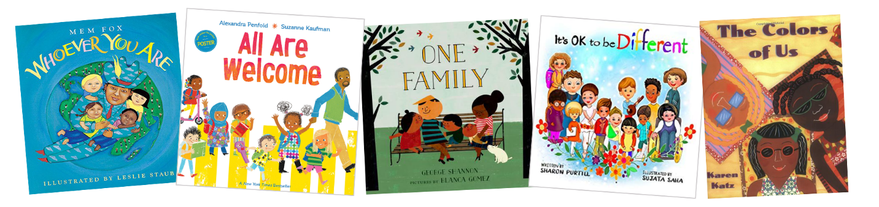

Whoever You Are by Mem Fox
Your child will enjoy looking at the colorful illustrations in this book about children all over the world. They might not all look the same and their lives may be different, but inside everyone is alike.

All Are Welcome by Alexandra Penfold
This story follows a group of students from all ethnic backgrounds as they go about their day at school. They are loved and welcomed for their differences, while learning about each other and the diverse world around them.

One Family by George Shannon
Families can look very different, and this book showcases that in a child-friendly way. They can be big or small and include people of various races and genders.

It’s OK to be Different by Sharon Purtill
This book celebrates differences of all kinds, including ethnicity, size, and personality. It encourages children to love what makes them unique and accept people who may not be like them. As the story says, “You should be kind to those who are different from you. Because to them, you are different too.”

The Colors of Us by Karen Katz
The main character, Lena, is a seven-year-old who wants to use brown paint to make a self-portrait. After a walk around her neighborhood with her mother, Lena realizes that there are many shades of brown skin and all are beautiful.

